Rivera, Patrick Jace L.

1.Good Design Websites (grandoreder.gamepress.gg)
-Main Page
Description of what kind of website is this
Easy Access of Menus

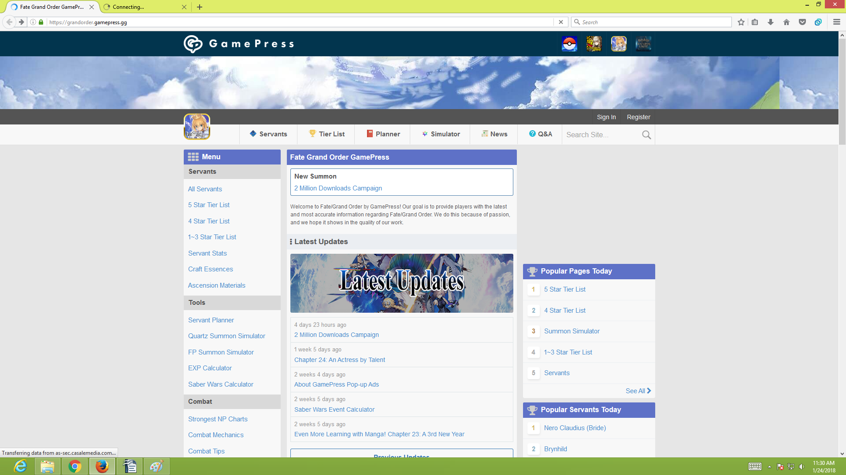
Latest Updates to know whats up
Easy to know what is the popular page of this website

Second Page

Easy Access of Menus
Choose what type of banner to simultate

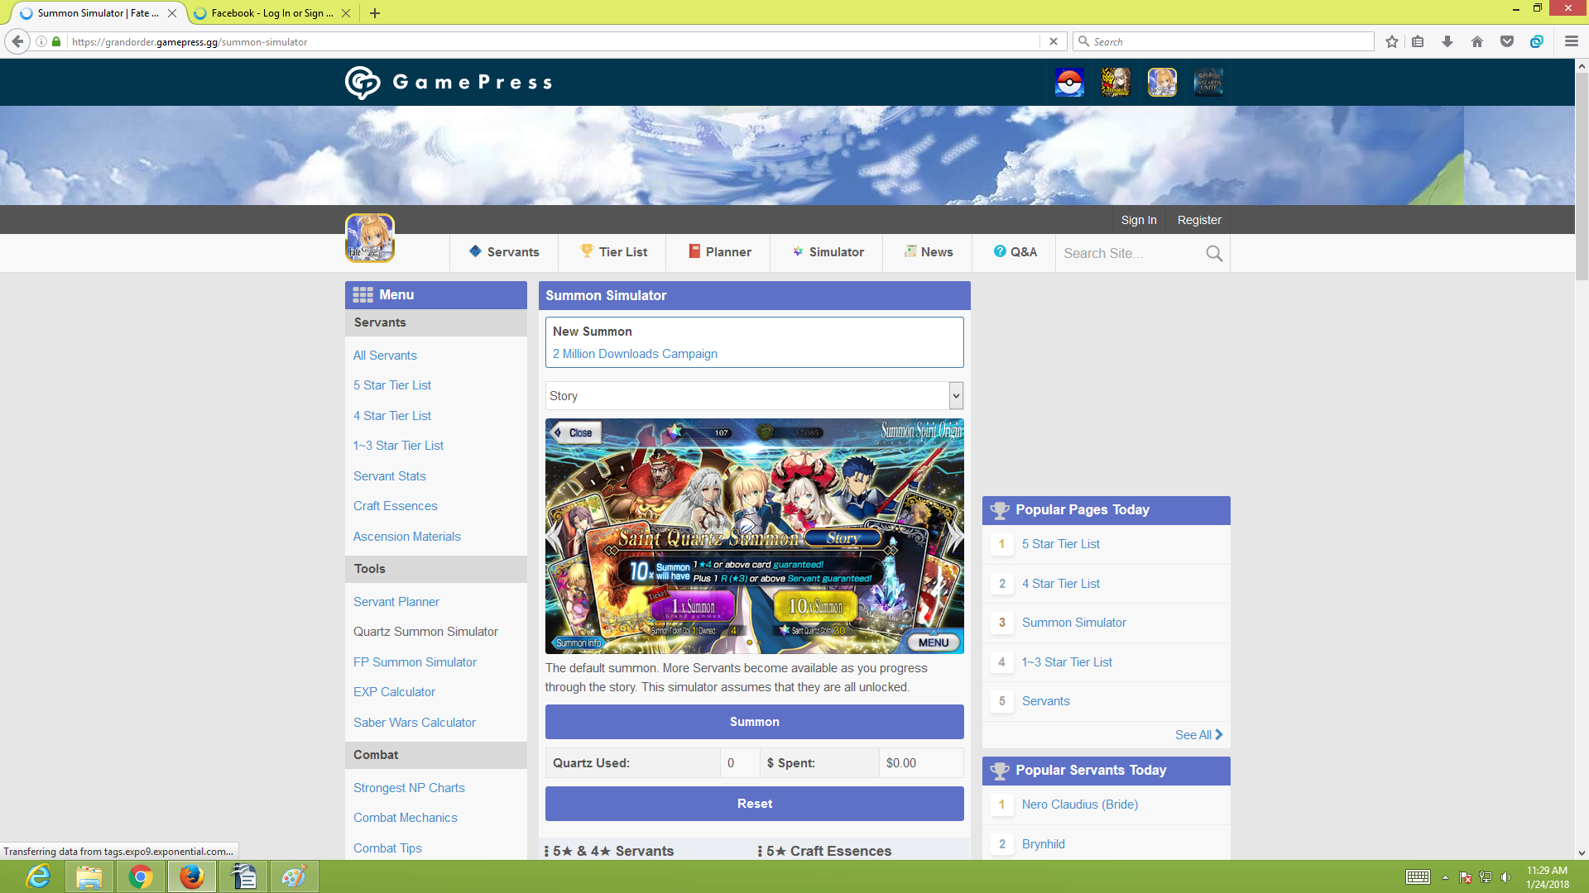
Simulation
To Reset the simulation
Description of quarts or money you may have used in the game
Easy to know what is the popular page of this website
Description of the banner chosen

2.Bad Design Websites
-Main Page
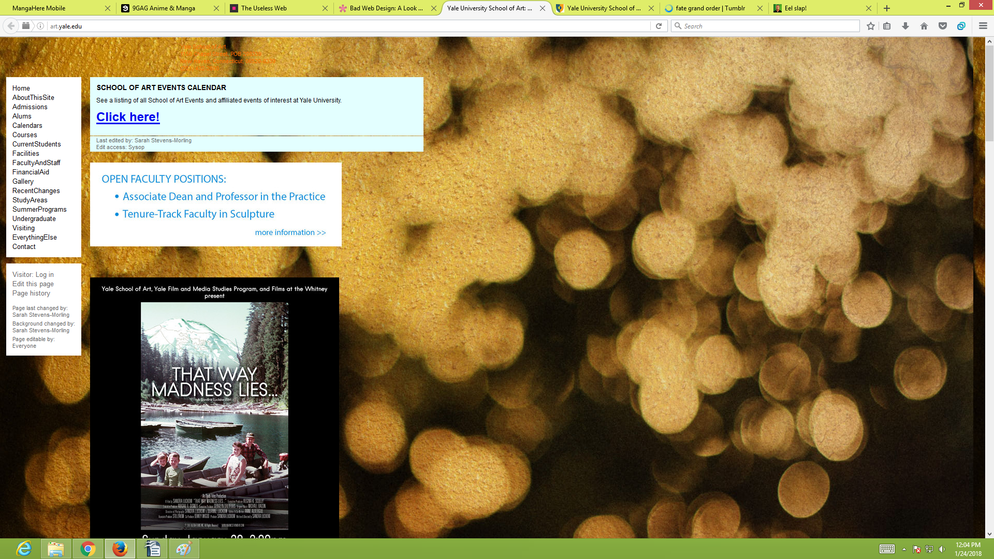
Unreadable text
Post are no alligned
Bad Design of Menu

Poor background Image

Too Many Space

Second page

Bad Design of Menu
Bad design of posts

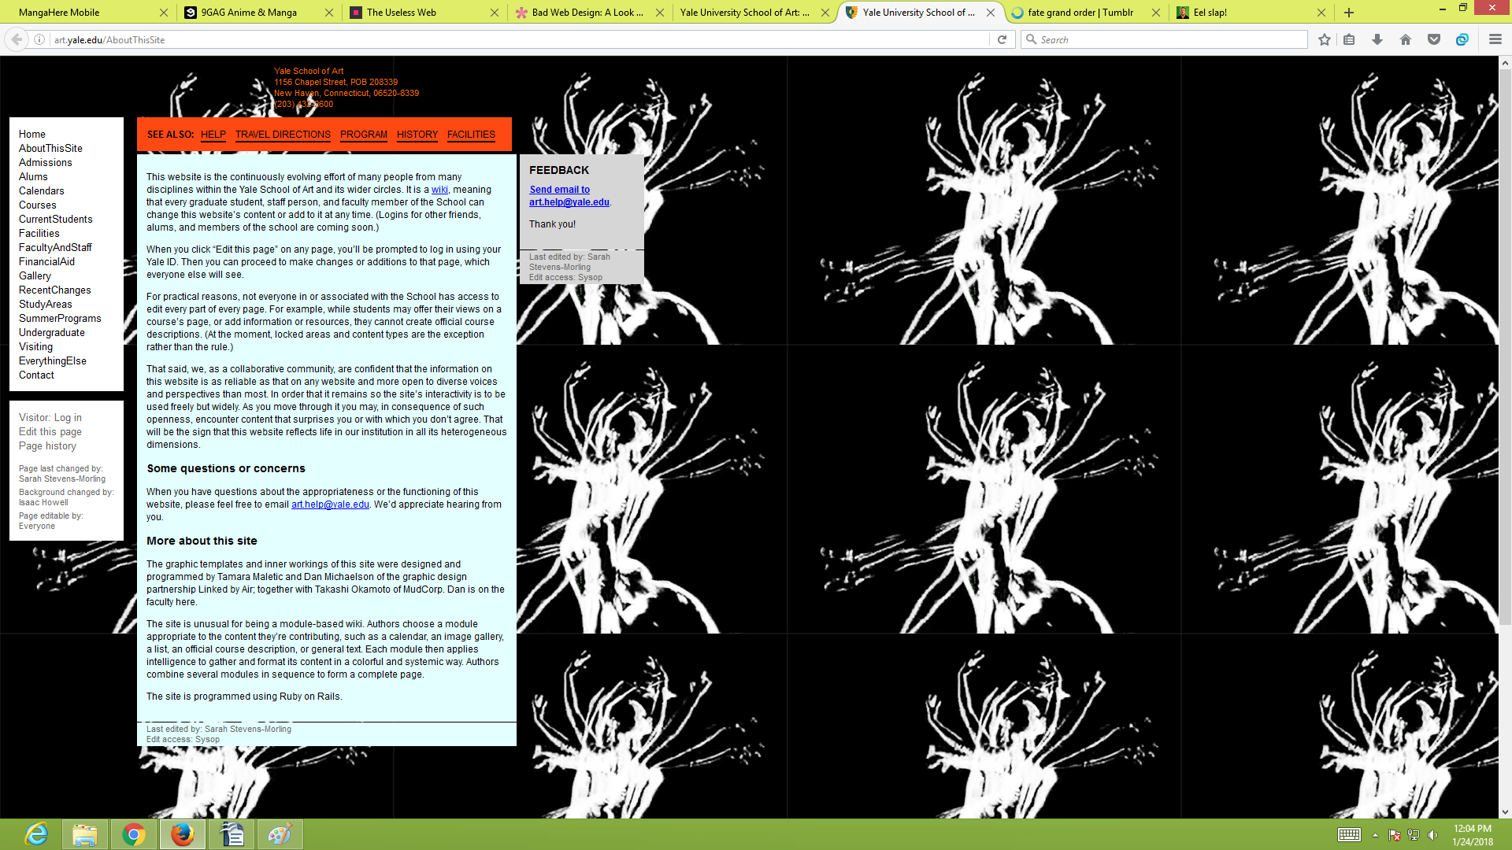

Still to many spaces

WTH Background Image

*At least align all the post and try to use the free space and try to create a better design of menus

3. Good Design
9gag has one of the most simple and clean web design mainly because on how they present it. Every space has its own purpose, the upper top most of design is used for signing in other pages while the center is used for the posts to be seen by users, right part is used for choosing what kind of post you want to see and the left part is for recommended posts. Whats good about it is that you don't have to click page 1,2,3 or more to see other posts instead in keeps on growing as you scroll down. Its simple and clean, no extenders to make the website complicated

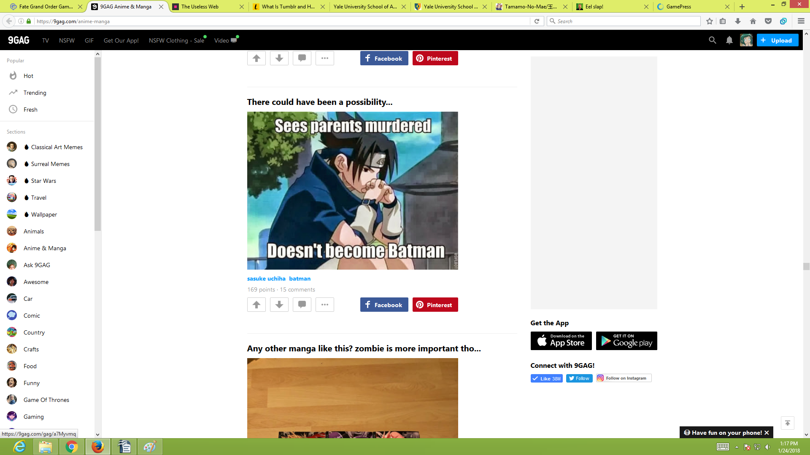

4. Good Navigation
grandorder gamepress is one of the best unique design of navigation. You can hide the naviagation by clicking the menu, what is great about this is that the navigation is all over the place but in a well deisgn.. some navigation is in the upper part, some is in the right side and some is in the left side. Once you enter the website, you won't feel lost, trust me I know (based on experience) and its so easy on what page you want to explore in this website.

- Design
Original


My Design
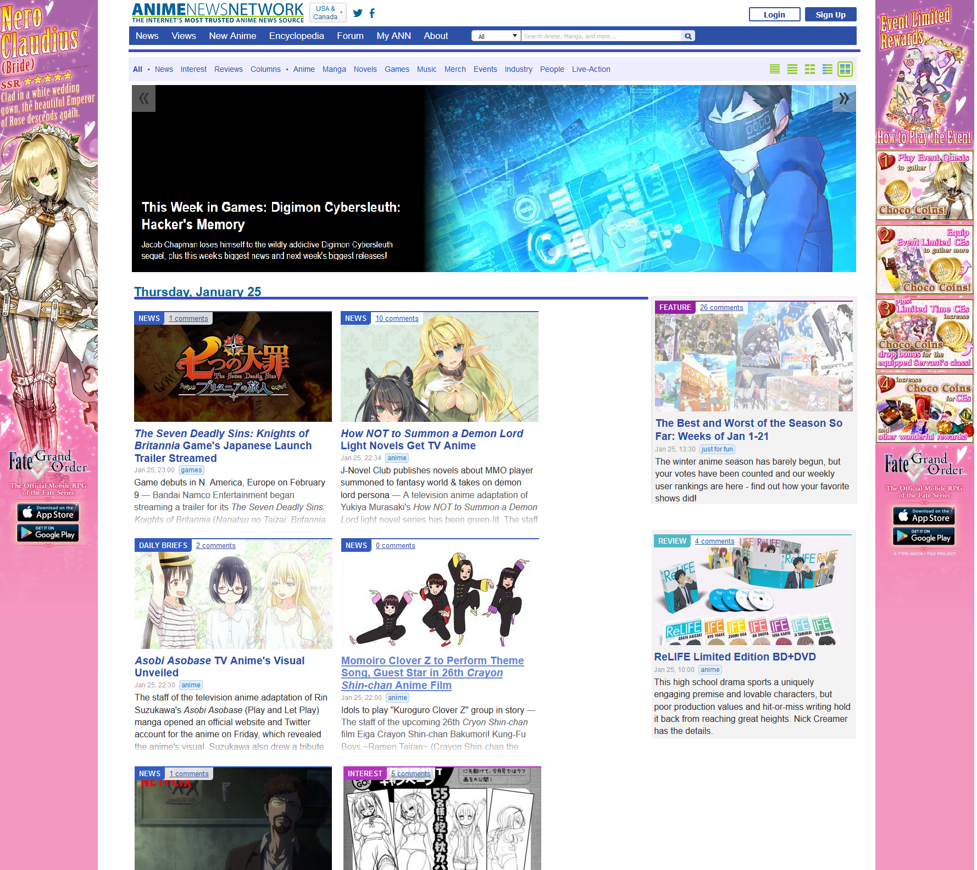
*Its simple and clean

6.WEBSITE
Some websites like 9gag, facebook seems the same but browser games like nutaku.net and others seems doesn't have the same functions.. in chrome and microsoft edge the game kamihime in nutaku seems to play very smoothly but in mozilla firefox isn't the same with other browsers. The page always crash as hell and you always have to wait for certain time for the game to load.

